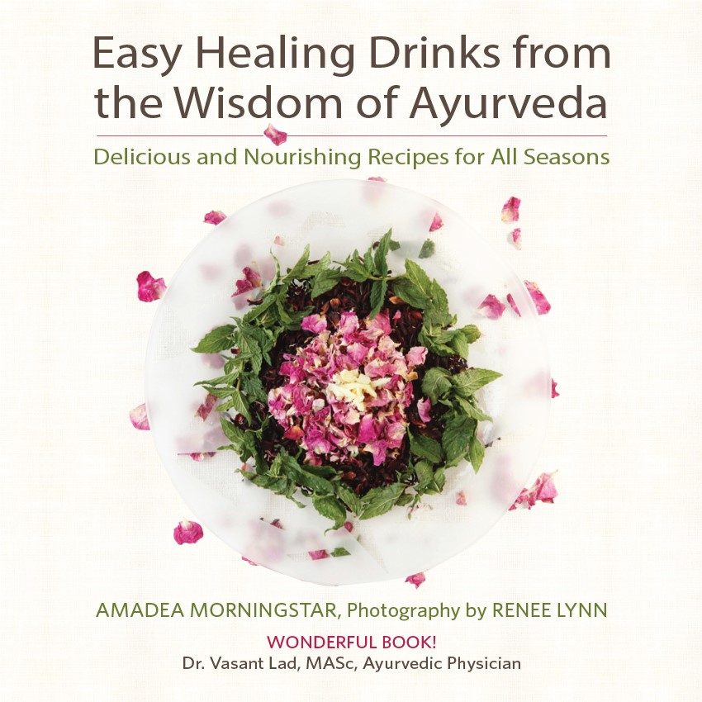  Saturday, Dec 1st  2:00-4:00  MAKE AYURVEDA & YOGA PART OF YOUR HOLIDAY  Delicious Book Signing Event with Amadea Morningstar  Stop in anytime and sample delicious and nutritious Ayurveda beverages, book signing, demonstration and Ayurveda information.  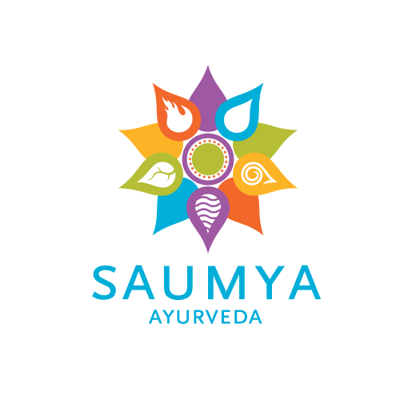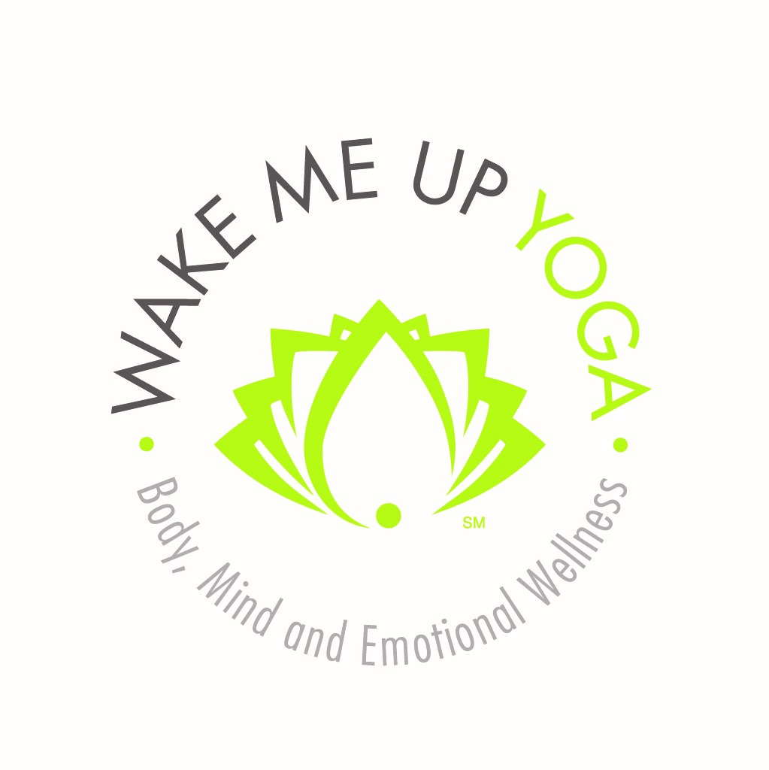 | Great Holiday Gift  ────  New Mexico’s own Amadea Morningstar  ────  Your Hosts:  Saumya Ayurveda  &  Wake Me Up Yoga  ────  Delicious Book Signing  ────  Drop In for a Moment or Stay for the Afternoon  Event Location:  Wake Me Up Yoga  4604 Corrales Road  Corrales NM 87048  505.803.5480  612.743.4289  Amadeamorningstar.net  saumya-ayurveda.com  wakemeupyoga.com

